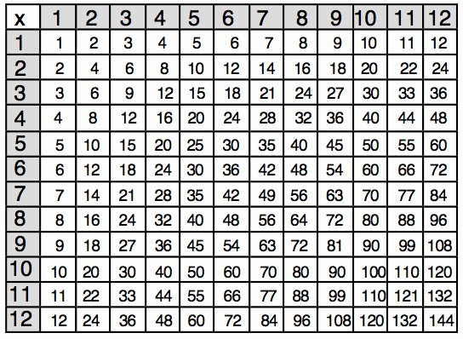

=

ANSWERS

In Middle

FACTORS

FACTORS