|  |  |  |  |  |  |  |
| --- | --- | --- | --- | --- | --- | --- |
| January | | | | | | |
| Sun. Mon. Tue. Wed. Thur. Fri. Sat. | | | | | | |
|  |  |  |  | **1** | **2** | **3** |
| **4** | **5** | **6** | **7** | **8** | **9** | **10** |
| **11** | **12** | **13** | **14** | **15** | **16** | **17** |
| **18** | **19** |  |  |  |  |  |
|  |  |  |  |  |  |  |

C:\Program Files (x86)\Microsoft Office\MEDIA\CAGCAT10\j0158007.wmf

1. **Today is _______________, January ___ 2015.**
2. **Yesterday was ________________________.**
3. **Tomorrow will be _____________________.**

**Unscramble:**

1. **SYE = __ __ __**
2. **HTAM = __ __ __ __**
3. C:\Program Files (x86)\Microsoft Office\MEDIA\CAGCAT10\j0158007.wmf**COLCK = __ __ __ __ __**

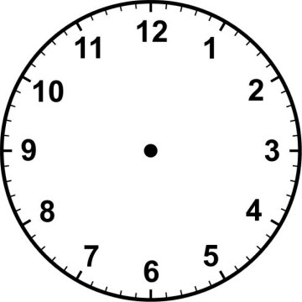

1. **The time is _____ : _____**
2. **20 + 10 = ________**
3. **41 + 10 = ________**
4. **How much money? __________________**
5. 